**Complaints db specifications**

**(Correct as at 31/03/2016)**

**By Alan Thompson**

**Technology and locations**

1. Front-end: MS Access 2003

(do not upgrade to 2010 etc, no need as should be developed easily in ASP.net/MVC/C# or other system from ICT).

1. Front-end Location: S:\Complaints\OHG Complaints Database v1.7

(S being the Corporate drive, no need to change the version each time new one is worked on, I simply copy over this one)

1. Back-end: Sql Server > ohg2k5sql01 > mark > cmp% prefixed tables, views etc.

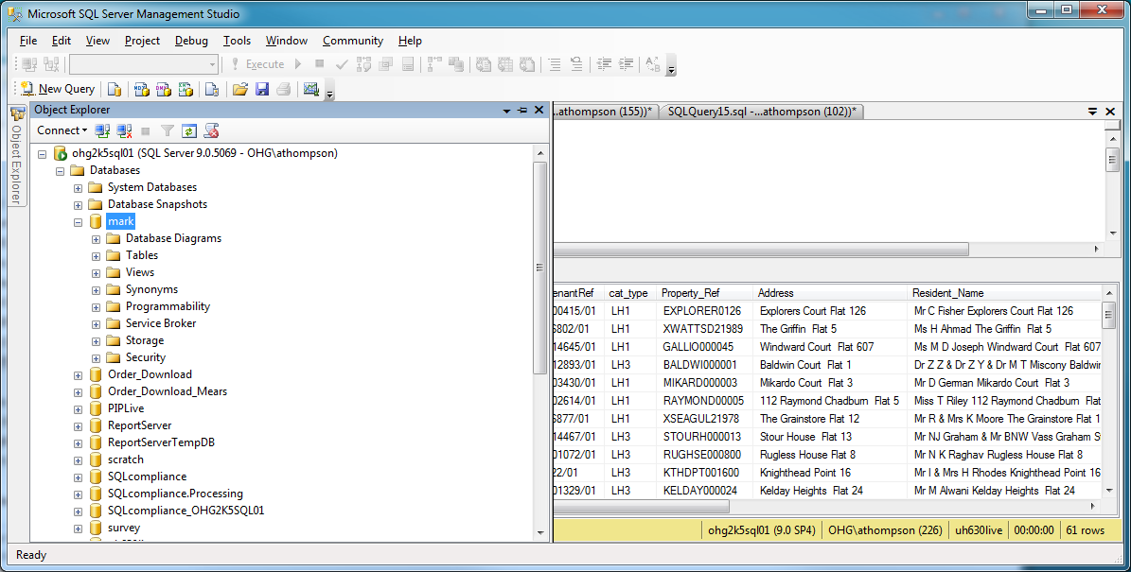

Main tables you need are:

3.1) cmpComplaints – this is the main ‘single’ record for a complaint and is continuous throughout the management of the complaint case. So stages will be updated here in the ‘current stage’.

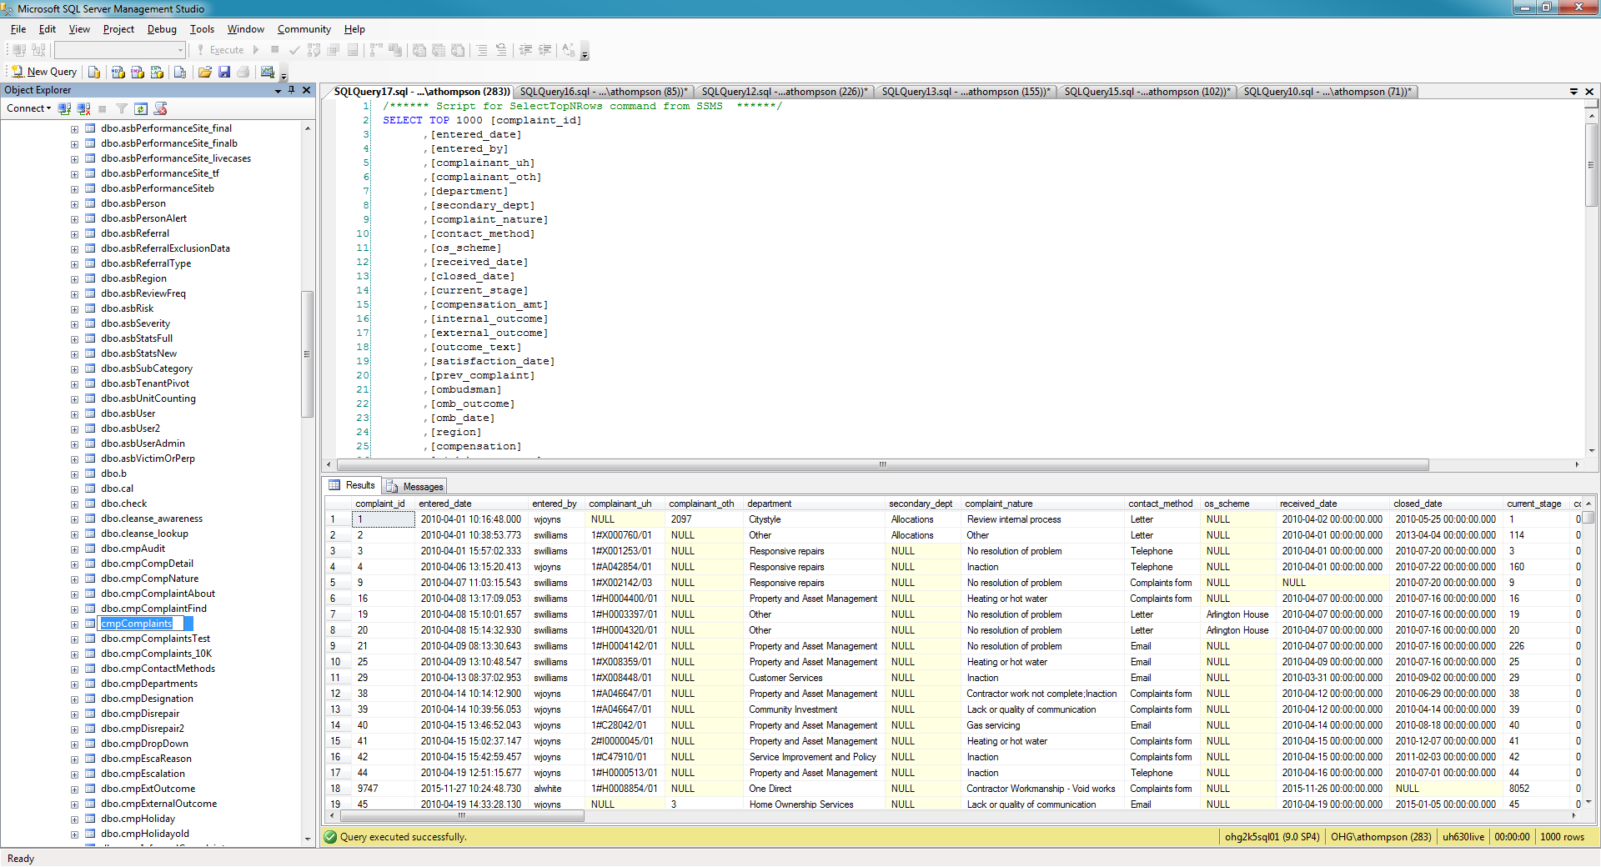

3.2) cmpStages – as per above, the ‘multiple’ stages/records are held here. For each new stage it is recorded here. Most of the other tables are related to minor forms in the access database or are lookup tables.

Please note relationship of the stage_complaint_id to the main cmpComplaints db’s Primary Key

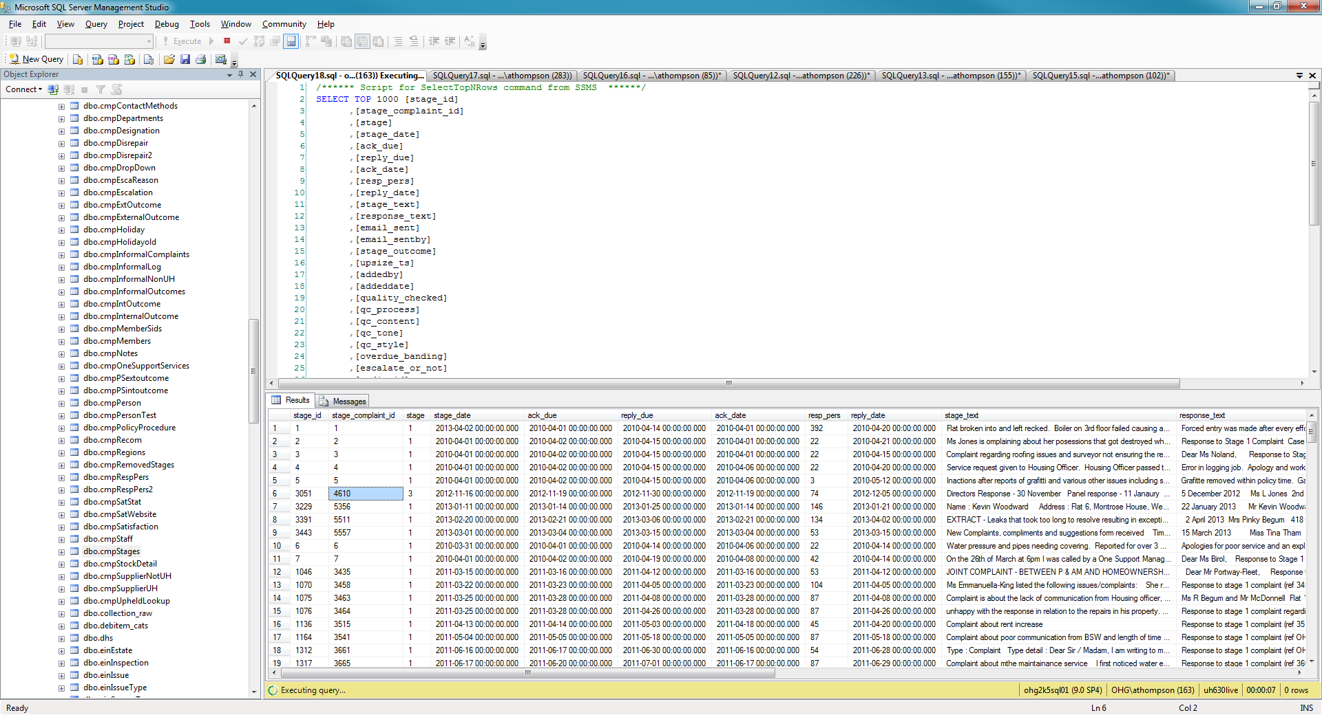

**You should note** this sql back-end is quite badly designed in the sense of normal form. It is not in 3NF and is quite denormalized really. There are also some hard coded lookups in the access db itself, which when found have been replaced with sql controlling tables. However, not done fully due to the fact this was only a temporary solution. For example we should not see ‘Citystyle’ in the department field. In 3nf, this should be a 1, 2, 3 etc.

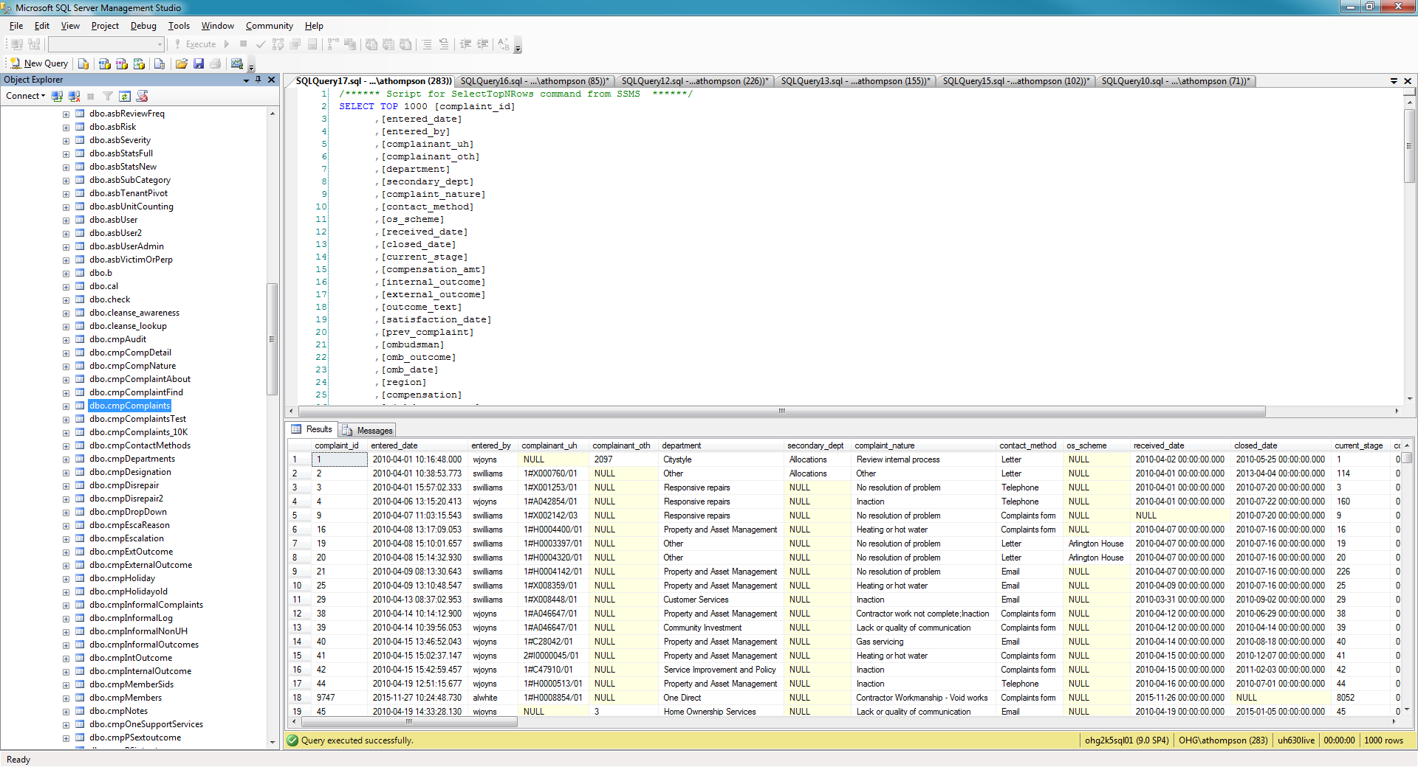

1. New development work on the access database or amendments, fixes and admin changes.

To develop, copy the db below to your local machine and make changes. Tip – you may find you open the db and it says ‘read only’ whereby you could not amend the vba/forms etc. However, if you make another copy of this file on your pc, the 2nd copy will allow write access to make your changes.

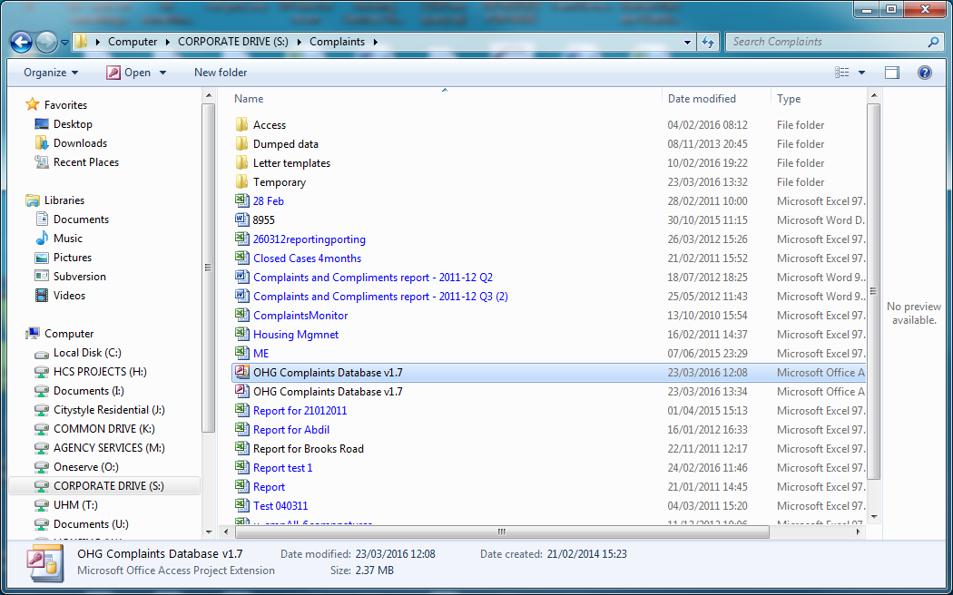

NB: you should ignore all the other files here unless stated. That is for the team alone. You should however, ensure that there are not multiple versions of the db on this drive.

1. Script: VBA

To develop the VBA – on the local copy,

Updating the live access db: Copy across and overwrite the file on the corporate drive, inform Complaints team and ask them to get out of the db, or it will NOT copy across anyway.

**ENSURE** you take a backup of the live one just in case before you overwrite, or if you have made changes that affect the live system, you will need to replace your defect copy with the original, then redevelop to fix improper changes.

1. Letter templates – see location below. The database will automatically open a letter at certain stages of the complaints process. At these points it is using the letters within this folder. They will ever so often require updates to text or fields in the letters to reflect changes in their internal process. To do this, you will need to again save the document from this location to your local drive. Then make text changes to this copy and then save back as a template document. Overwriting the original – after taking a backup of course.

DO NOT just use the word document they send, as inevitably it will not have the pre-populated fields which to add you would need to get into unnecessary already completed development.

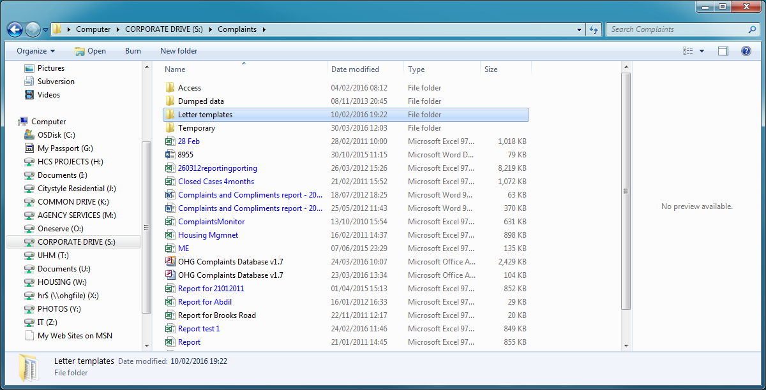

Obviously the names are very important and can be seen if you open the VBA of the db to see how they are opened on button clicks therein.

Note: the VBA is pretty straight forward – if you can do VBA so this specification is NOT going into any tutorial on updating or amending current VBA. It is however a fact that any sql insertion of form data via this front-end of access – will require a fair bit of VBA to be replicated for the new aspect.

This spec will also not go into any tutorial on how to update the templates but I can point out that if you drag the mouse to select as shown below, you can see the existing fields. Plus if you are in the front-end and create a letter, you will immediately see where the fields are populated.

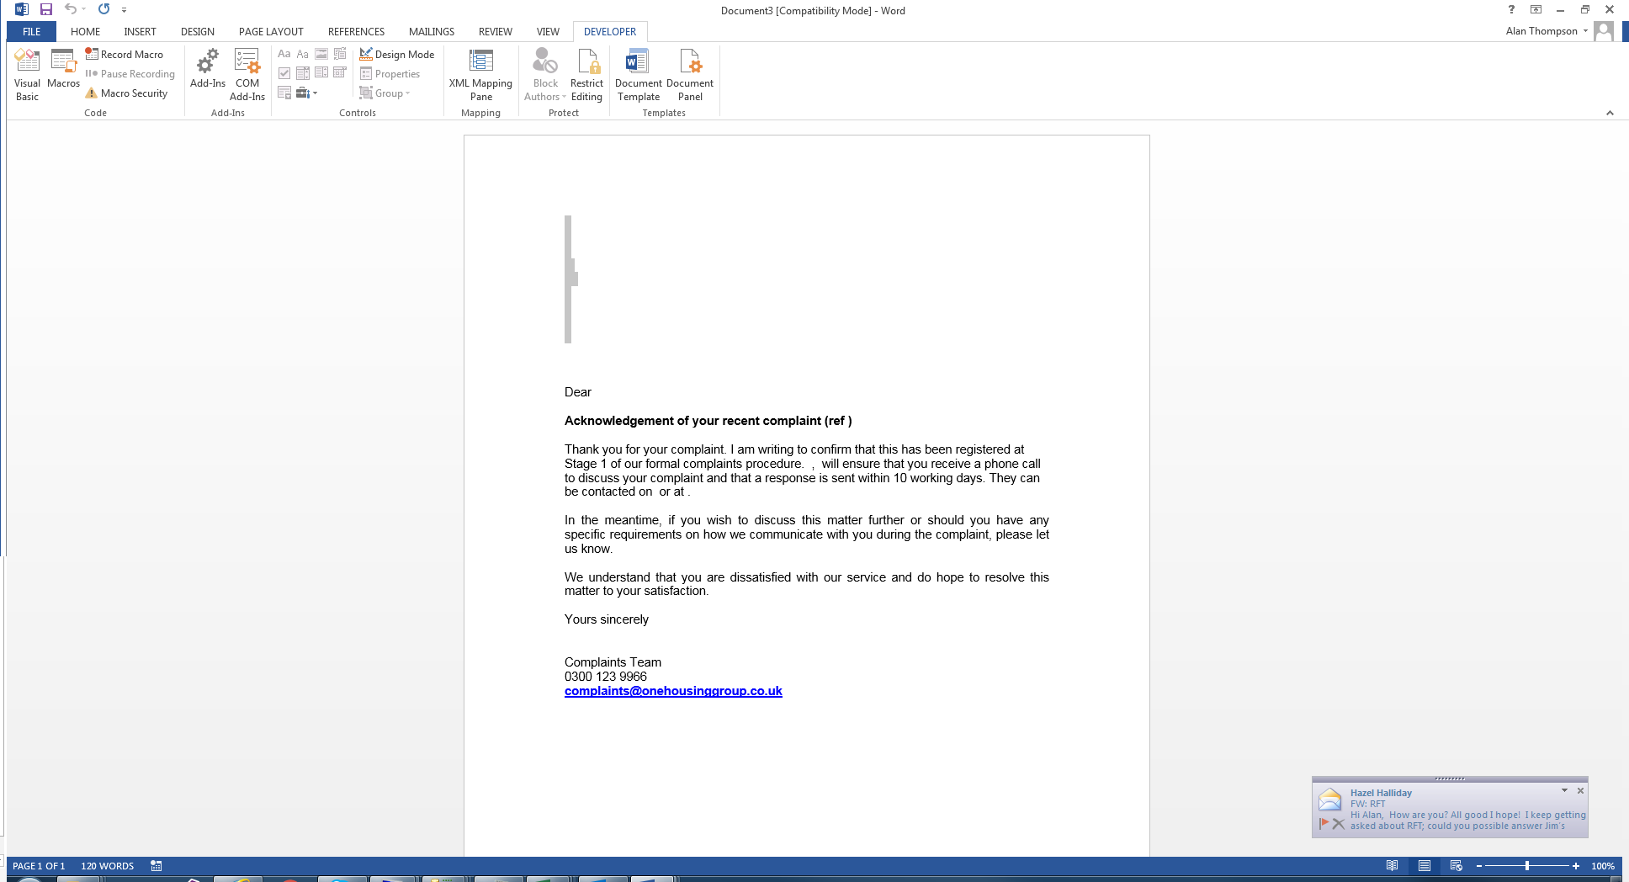

1. User setup

Whilst the team have the self service tool and so this has eliminated any actual need to have ICT add users now. Users may email you or the Sn or ICT helpdesk, or call them and be referred to you. This is a support matter really and so helpdesk should do it by using the informal complaints page. Or just by updating the sql table directly:

7.1) first check the user does not already exist

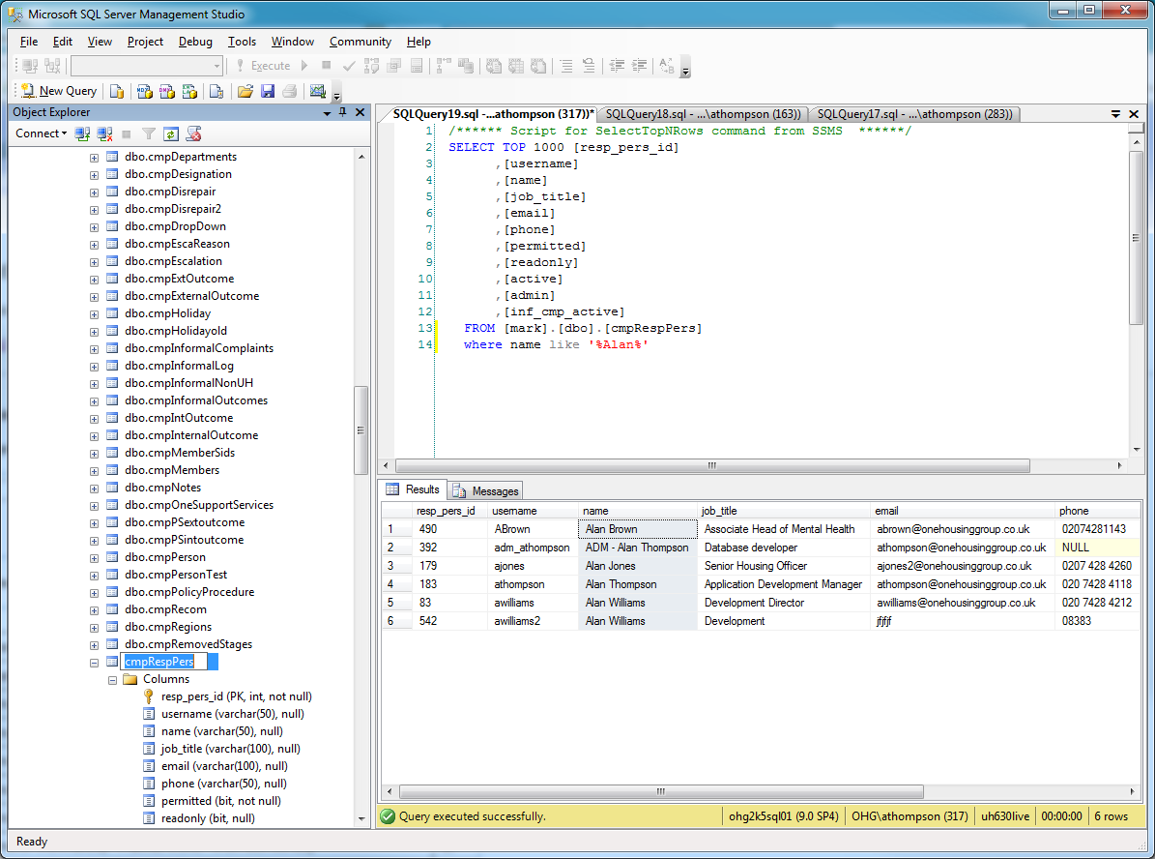

7.2) then if they DO NOT, you can add them. The username is a PK or at least must be unique, so duplicates are not allowed hence the failure below. If they can be added, right click the cmpRespPers table as shown here, to edit the table.

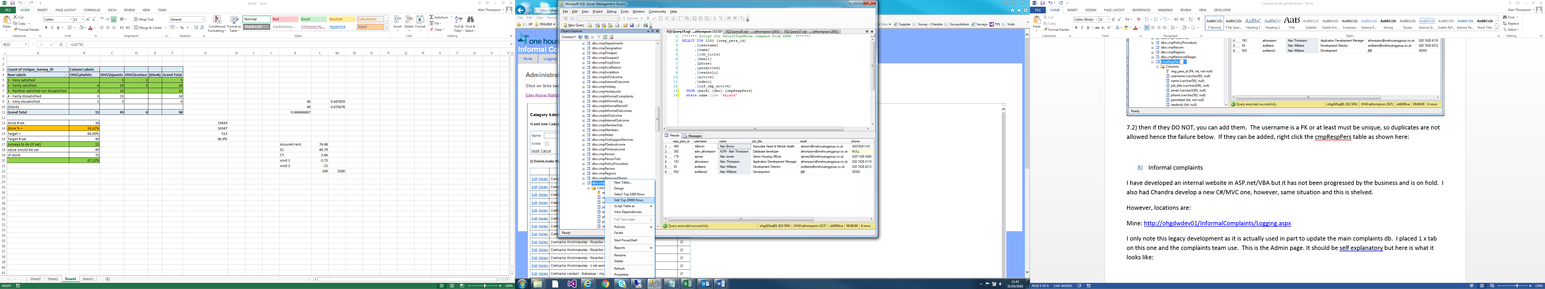

And in edit, type in the details (not the id as automatic/identity) and ensure you give them the right access. Unlike some of the other access db’s, this one does need full details if possible, ie username (most important or they CANNOT use the db) , name, title, email – for admin purposes by the team. The other fields such as readonly, active and admin are self explanatory.

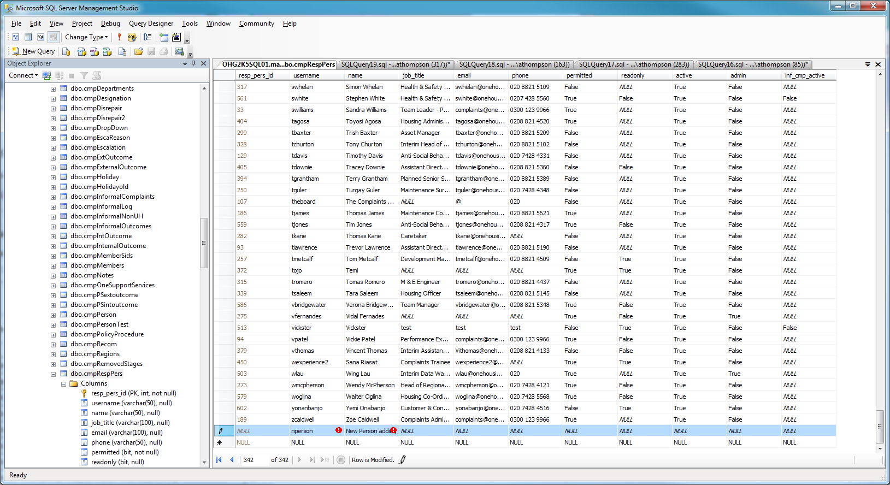

1. Informal complaints

I have developed an internal website in ASP.net/VBA but it has not been progressed by the business and is on hold. I also had Chandra develop a new C#/MVC one, however, same situation and this is shelved.

However, locations are:

Mine: <http://ohgdwdev01/InformalComplaints/Logging.aspx>

I only note this legacy development as it is actually used in part to update the main complaints db. I placed 1 x tab on this one and the complaints team use. This is the Admin page. It should be self explanatory but here is what it looks like:

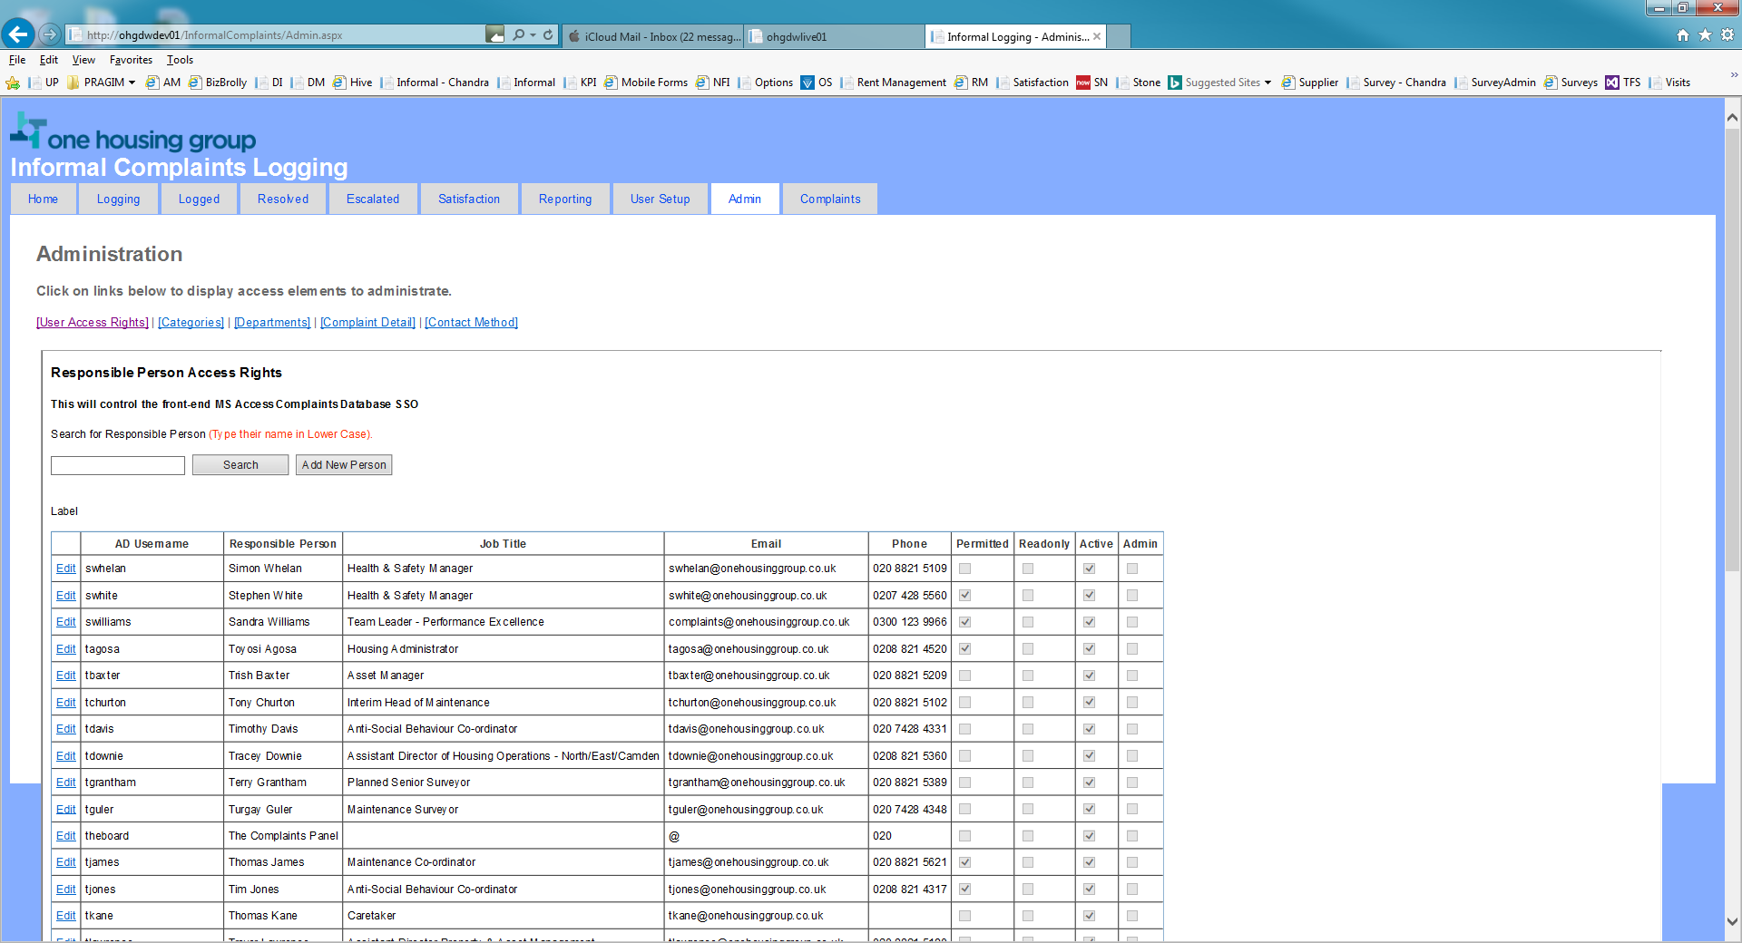

This allows self service for:

User CRUD (Creating users, looking at current users, updating current users and Deleting current users – albeit by making them inactive)

Here if you click the Add New person button.

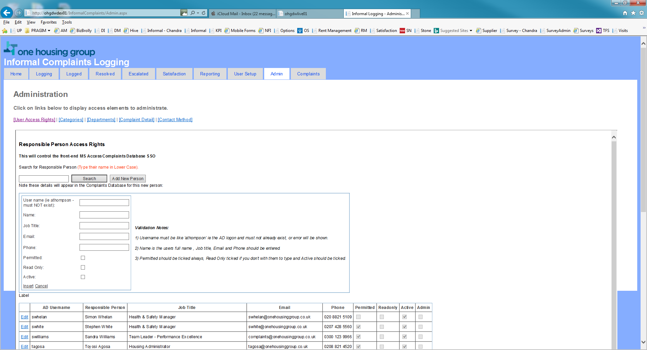

NB: one flaw not handled as no further dev, however, users know not to do it. If you click to add someone that is already there, it will throw this asp.net standard error, instead a popup should be added to say ‘user already exists’ though this is why there is a search box for them to check if there first.

The self service extends to other key lookups that the access db utilises:

Categories, Departments, Complaint Detail and Contact Method, see related hyperlinks:

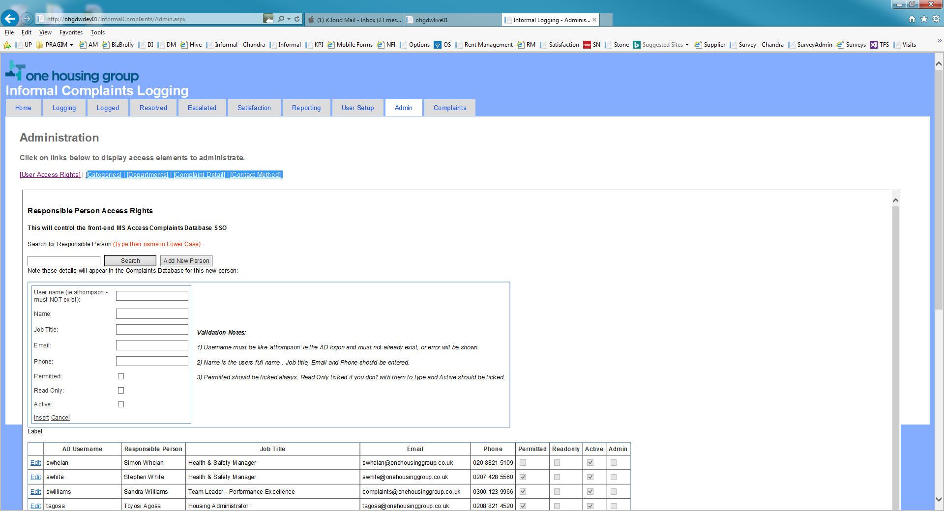

Each are designed in a very similar way to allow for CRUD on these lookups. Noting changes affect the live db.

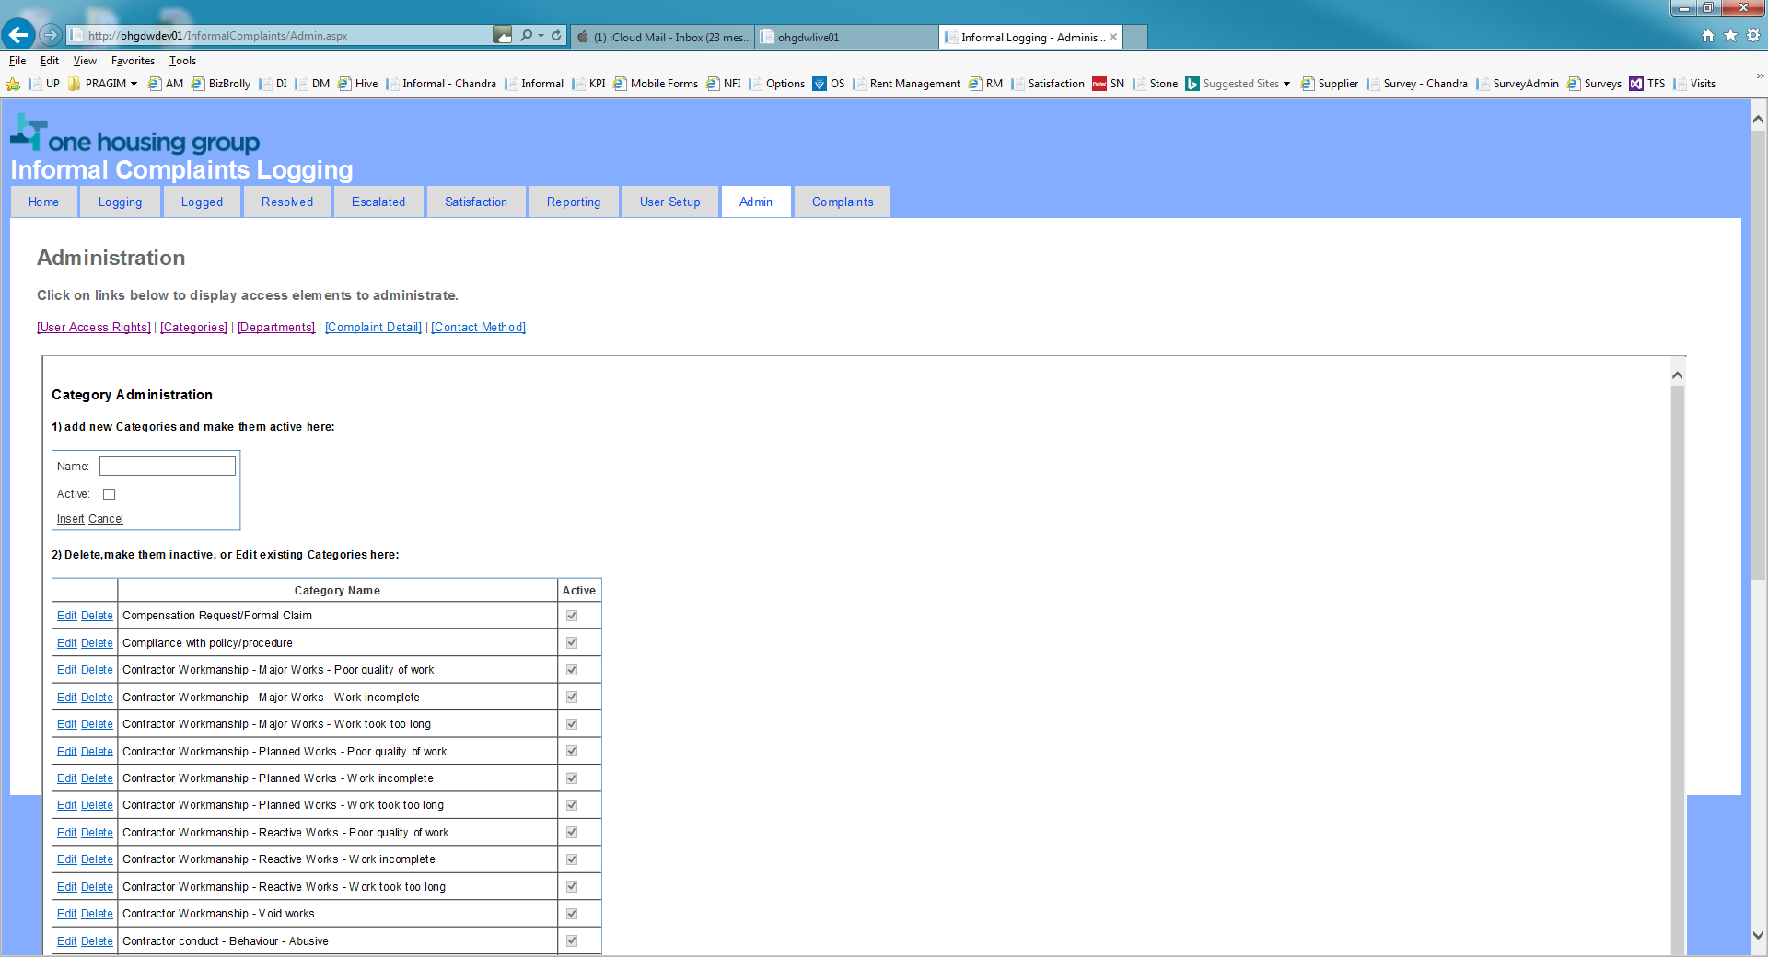

Chandra’s:

<http://ohgdwlive01/InformalComplaints/ICHome>

More developed, though without admin functions yet (above), will see added functions not developed in the original yet, to email users when an informal complaint is allocated to them – using the AD:

Though I think the email has fallen over.

